Title of the Abstract (16pt Arial Bold)
Author (San Zhang)^{1,#}, Second Author(initial surname.) ², Corresponding Author(initial surname)^{1,*} (12pt Times New Roman Bold)
¹Department of Physics, University of xxxxxx, Postal address, City, Post code
²Institut of Physics, Chinese Academy of Sciences, Postal address, City, Post code
#Email: xxx@xxx
Abstract text in English, Times New Roman, 300 words maximum (10pt Times New Roman )
(The abstract should be limited to only one page!)
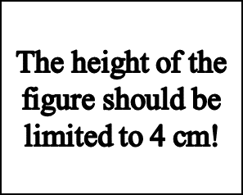
Fig. 1 Figure title in English
Key Words: one, two, three, four, five (No more than 5)
Reference
[1] Zhang, S.; Li, S.; Zhou, W.; Zheng, L. Chem. 2021, 1: 14304.

